【我的妹妹聽不見】閱讀學習單
\s\up9(\o(\s\up3(\d\fo4()ˇ)\s\up9(\o(\s\up3(\d\fo0()ˊ)\s\up9(\o(\s\up3(\d\fo0()ˇ)，\s\up9(\o(\s\up3(\d\fo0()ˋ)\s\up9(\o(\s\up3(\d\fo0()ˊ)\s\up9(\o(\s\up0(\d\ba11()˙)\s\up9(\o(\s\up3(\d\fo0()ˋ)\s\up9(\o(\s\up0(\d\ba11()˙)\s\up9(\o(\s\up3(\d\fo0()ˋ)\s\up9(\o(\s\up3(\d\ba7()ˋ)\s\up9(\o(\s\up3(\d\fo4()ˇ)\s\up9(\o(\s\up3(\d\fo0()ˇ)\s\up9(\o(\s\up3(\d\fo0()ˋ)\s\up9(ㄒㄧㄣ)ㄒㄧㄣ\s\up9(ㄒㄧㄣ))\s\up9(ㄒㄧㄣ)\s\up9(\o(\s\up3(\d\fo4()ˇ)\s\up9(\o(\s\up3(\d\ba7()ˋ)\s\up9(\o(\s\up3(\d\fo4()ˇ)，\s\up9(\o(\s\up3(\d\fo4()ˋ)\s\up9(\o(\s\up3(\d\fo4()ˊ)\s\up9(\o(\s\up3(\d\fo0()ˊ)\s\up9(\o(\s\up3(\d\fo4()ˋ)\s\up9(\o(\s\up3(\d\fo4()ˋ)\s\up9(\o(\s\up0(\d\ba11()˙)\s\up9(\o(\s\up3(\d\fo0()ˋ)\s\up9(\o(\s\up3(\d\fo0()ˊ)：
一、\s\up9(\o(\s\up3(\d\fo0()ˋ)\s\up9(\o(\s\up3(\d\fo0()ˋ)\s\up9(\o(\s\up0(\d\ba11()˙)\s\up9(\o(\s\up3(\d\ba7()ˇ)\s\up9(\o(\s\up0(\d\ba12()˙)\s\up9(\o(\s\up3(\d\fo4()ˊ)\s\up9(\o(\s\up0(\d\ba11()˙)，\s\up9(ㄊㄚ)ㄊㄚ\s\up9(ㄊㄚ))\s\up9(ㄊㄚ)\s\up9(\o(\s\up0(\d\ba11()˙)\s\up9(\o(\s\up3(\d\ba7()ˇ)\s\up9(\o(\s\up0(\d\ba12()˙)\s\up9(\o(\s\up3(\d\fo4()ˋ)\s\up9(\o(\s\up3(\d\fo0()ˊ)\s\up9(\o(\s\up3(\d\fo4()ˋ)\s\up9(\o(\s\up3(\d\fo4()ˋ)？
\s\up9(\o(\s\up3(\d\fo0()ˊ)：□\s\up9(\o(\s\up3(\d\fo4()ˋ) □\s\up9(\o(\s\up3(\d\fo0()ˊ)\s\up9(\o(\s\up3(\d\fo4()ˋ)
二、\s\up9(\o(\s\up3(\d\fo4()ˇ)\s\up9(\o(\s\up3(\d\fo4()ˇ)\s\up9(\o(\s\up3(\d\fo0()ˋ)\s\up9(\o(\s\up3(\d\fo0()ˊ)\s\up9(\o(\s\up0(\d\ba11()˙)\s\up9(ㄈㄤ)ㄈㄤ\s\up9(ㄈㄤ))\s\up9(ㄈㄤ)\s\up9(\o(\s\up3(\d\ba7()ˋ)\s\up9(\o(\s\up3(\d\fo0()ˋ)\s\up9(\o(\s\up3(\d\fo0()ˋ)\s\up9(\o(\s\up3(\d\fo0()ˋ)\s\up9(\o(\s\up3(\d\fo4()ˊ)\s\up9(\o(\s\up3(\d\fo0()ˊ)\s\up9(ㄊㄚ)ㄊㄚ\s\up9(ㄊㄚ))\s\up9(ㄊㄚ)\s\up9(\o(\s\up0(\d\ba11()˙)\s\up9(\o(\s\up3(\d\ba7()ˋ)\s\up9(ㄙ)ㄙ\s\up9(ㄙ))\s\up9(ㄙ)？
\s\up9(\o(\s\up3(\d\fo0()ˊ)：□\s\up9(\o(\s\up3(\d\fo0()ˋ)\s\up9(\o(\s\up3(\d\fo4()ˋ) □\s\up9(\o(\s\up3(\d\fo0()ˇ)\s\up9(\o(\s\up3(\d\ba7()ˋ)\s\up9(\o(\s\up3(\d\fo0()ˋ)\s\up9(\o(\s\up3(\d\fo4()ˇ)\s\up9(\o(\s\up3(\d\fo4()ˊ)
三、\s\up9(\o(\s\up3(\d\fo0()ˋ)\s\up9(\o(\s\up3(\d\fo0()ˋ)\s\up9(\o(\s\up3(\d\fo0()ˋ)\s\up9(\o(\s\up3(\d\fo0()ˊ)\s\up9(\o(\s\up0(\d\ba11()˙)\s\up9(\o(\s\up3(\d\fo0()ˋ)\s\up9(\o(\s\up3(\d\fo0()ˊ)\s\up9(\o(\s\up3(\d\fo4()ˋ)\s\up9(\o(\s\up3(\d\fo4()ˇ)\s\up9(\o(\s\up3(\d\fo4()ˇ)\s\up9(\o(\s\up0(\d\ba11()˙)\s\up9(\o(\s\up3(\d\fo0()ˇ)\s\up9(\o(\s\up3(\d\fo4()ˋ)？
\s\up9(\o(\s\up3(\d\fo0()ˊ)：□\s\up9(\o(\s\up3(\d\fo0()ˋ)\s\up9(\o(\s\up3(\d\fo0()ˋ)\s\up9(\o(\s\up3(\d\fo0()ˇ)\s\up9(\o(\s\up3(\d\fo4()ˇ)\s\up9(\o(\s\up3(\d\fo0()ˋ)\s\up9(\o(\s\up3(\d\fo0()ˇ)\s\up9(\o(\s\up3(\d\fo4()ˋ) □\s\up9(\o(\s\up3(\d\fo0()ˋ)\s\up9(\o(\s\up3(\d\fo0()ˋ)\s\up9(\o(\s\up3(\d\fo4()ˇ)\s\up9(\o(\s\up3(\d\fo0()ˋ)\s\up9(\o(\s\up3(\d\fo0()ˋ)\s\up9(\o(\s\up3(\d\fo4()ˇ)\s\up9(\o(\s\up3(\d\fo4()ˇ)\s\up9(\o(\s\up0(\d\ba11()˙)\s\up9(\o(\s\up3(\d\fo4()ˇ)\s\up9(\o(\s\up3(\d\fo4()ˊ)
四、\s\up9(\o(\s\up3(\d\fo0()ˋ)\s\up9(\o(\s\up3(\d\fo0()ˋ)\s\up9(\o(\s\up3(\d\fo0()ˇ)\s\up9(\o(\s\up3(\d\ba7()ˇ)\s\up9(\o(\s\up3(\d\fo0()ˋ)\s\up9(\o(\s\up3(\d\fo0()ˇ)\s\up9(ㄐㄧㄥ)ㄐㄧㄥ\s\up9(ㄐㄧㄥ))\s\up9(ㄐㄧㄥ)\s\up9(\o(\s\up3(\d\fo0()ˋ)\s\up9(\o(\s\up3(\d\fo0()ˇ)\s\up9(\o(\s\up3(\d\fo0()ˇ)\s\up9(\o(\s\up3(\d\fo4()ˊ)\s\up9(\o(\s\up3(\d\fo0()ˋ)\s\up9(\o(\s\up3(\d\fo0()ˊ)\s\up9(\o(\s\up0(\d\ba11()˙)\s\up9(\o(\s\up3(\d\fo0()ˋ)\s\up9(\o(\s\up0(\d\ba11()˙)\s\up9(ㄕㄥ)ㄕㄥ\s\up9(ㄕㄥ))\s\up9(ㄕㄥ)\s\up9(ㄧㄣ)ㄧㄣ\s\up9(ㄧㄣ))\s\up9(ㄧㄣ)？
\s\up9(\o(\s\up3(\d\fo0()ˊ)：□\s\up9(ㄇㄠ)ㄇㄠ\s\up9(ㄇㄠ))\s\up9(ㄇㄠ)\s\up9(\o(\s\up3(\d\fo4()ˋ)\s\up9(\o(\s\up0(\d\ba11()˙)\s\up9(ㄕㄥ)ㄕㄥ\s\up9(ㄕㄥ))\s\up9(ㄕㄥ)\s\up9(ㄧㄣ)ㄧㄣ\s\up9(ㄧㄣ))\s\up9(ㄧㄣ) □\s\up9(\o(\s\up3(\d\fo0()ˊ)\s\up9(\o(\s\up3(\d\fo4()ˊ)\s\up9(\o(\s\up0(\d\ba11()˙)\s\up9(ㄕㄥ)ㄕㄥ\s\up9(ㄕㄥ))\s\up9(ㄕㄥ)\s\up9(ㄧㄣ)ㄧㄣ\s\up9(ㄧㄣ))\s\up9(ㄧㄣ) □\s\up9(ㄕㄡ)ㄕㄡ\s\up9(ㄕㄡ))\s\up9(ㄕㄡ)\s\up9(ㄧㄣ)ㄧㄣ\s\up9(ㄧㄣ))\s\up9(ㄧㄣ)\s\up9(ㄐㄧ)ㄐㄧ\s\up9(ㄐㄧ))\s\up9(ㄐㄧ)\s\up9(\o(\s\up0(\d\ba11()˙)\s\up9(ㄕㄥ)ㄕㄥ\s\up9(ㄕㄥ))\s\up9(ㄕㄥ)\s\up9(ㄧㄣ)ㄧㄣ\s\up9(ㄧㄣ))\s\up9(ㄧㄣ)
五、\s\up9(\o(\s\up3(\d\fo4()ˇ)\s\up9(\o(\s\up3(\d\fo4()ˇ)\s\up9(\o(\s\up3(\d\fo4()ˋ)\s\up9(\o(\s\up3(\d\fo0()ˋ)\s\up9(\o(\s\up3(\d\fo0()ˋ)\s\up9(\o(\s\up3(\d\fo0()ˇ)\s\up9(\o(\s\up3(\d\fo0()ˋ)\s\up9(\o(\s\up3(\d\fo0()ˇ)？\s\up9(ㄊㄚ)ㄊㄚ\s\up9(ㄊㄚ))\s\up9(ㄊㄚ)\s\up9(\o(\s\up3(\d\fo0()ˇ)\s\up9(\o(\s\up3(\d\fo0()ˋ)\s\up9(\o(\s\up3(\d\fo4()ˋ)\s\up9(\o(\s\up3(\d\fo0()ˋ)\s\up9(\o(\s\up3(\d\fo0()ˋ)\s\up9(\o(\s\up3(\d\fo0()ˋ)？
\s\up9(\o(\s\up3(\d\fo0()ˊ)：（ ）
六、\s\up9(\o(\s\up3(\d\fo0()ˊ)\s\up9(\o(\s\up3(\d\fo4()ˇ)\s\up9(\o(\s\up3(\d\fo0()ˊ)\s\up9(\o(\s\up0(\d\ba11()˙)\s\up9(\o(\s\up3(\d\fo0()ˋ)\s\up9(\o(\s\up3(\d\fo0()ˊ)\s\up9(\o(\s\up3(\d\fo4()ˇ)\s\up9(\o(\s\up3(\d\fo4()ˇ)\s\up9(\o(\s\up3(\d\fo0()ˋ)\s\up9(\o(\s\up3(\d\fo0()ˋ)，\s\up9(\o(\s\up3(\d\fo0()ˇ)\s\up9(\o(\s\up3(\d\fo4()ˊ)\s\up9(\o(\s\up0(\d\ba11()˙)\s\up9(\o(\s\up3(\d\fo0()ˋ)\s\up9(\o(\s\up3(\d\fo0()ˋ)\s\up9(\o(\s\up3(\d\fo4()ˋ)\s\up9(\o(\s\up3(\d\fo0()ˇ)\s\up9(\o(\s\up3(\d\fo0()ˋ)？
\s\up9(\o(\s\up3(\d\fo0()ˊ)：（ ）
七、\s\up9(\o(\s\up3(\d\fo4()ˇ)\s\up9(\o(\s\up3(\d\fo0()ˊ)\s\up9(\o(\s\up3(\d\fo0()ˇ)\s\up9(ㄓㄡ)ㄓㄡ\s\up9(ㄓㄡ))\s\up9(ㄓㄡ)\s\up9(\o(\s\up3(\d\fo0()ˊ)\s\up9(\o(\s\up3(\d\fo0()ˇ)\s\up9(\o(\s\up3(\d\fo0()ˋ)\s\up9(\o(\s\up3(\d\fo0()ˇ)\s\up9(\o(\s\up3(\d\fo0()ˋ)\s\up9(\o(\s\up3(\d\ba7()ˊ)\s\up9(\o(\s\up3(\d\fo0()ˋ)\s\up9(\o(\s\up0(\d\ba11()˙)\s\up9(\o(\s\up3(\d\fo0()ˊ)，\s\up9(\o(\s\up3(\d\fo0()ˇ)\s\up9(\o(\s\up3(\d\fo4()ˋ)\s\up9(\o(\s\up3(\d\fo0()ˇ)\s\up9(\o(\s\up3(\d\fo0()ˋ)\s\up9(\o(\s\up3(\d\fo0()ˋ)\s\up9(ㄊㄚ)ㄊㄚ\s\up9(ㄊㄚ))\s\up9(ㄊㄚ)\s\up9(\o(\s\up0(\d\ba11()˙)\s\up9(ㄒㄧㄤ)ㄒㄧㄤ\s\up9(ㄒㄧㄤ))\s\up9(ㄒㄧㄤ)\s\up9(\o(\s\up3(\d\fo0()ˇ)？
\s\up9(\o(\s\up3(\d\fo0()ˊ)：（ ）
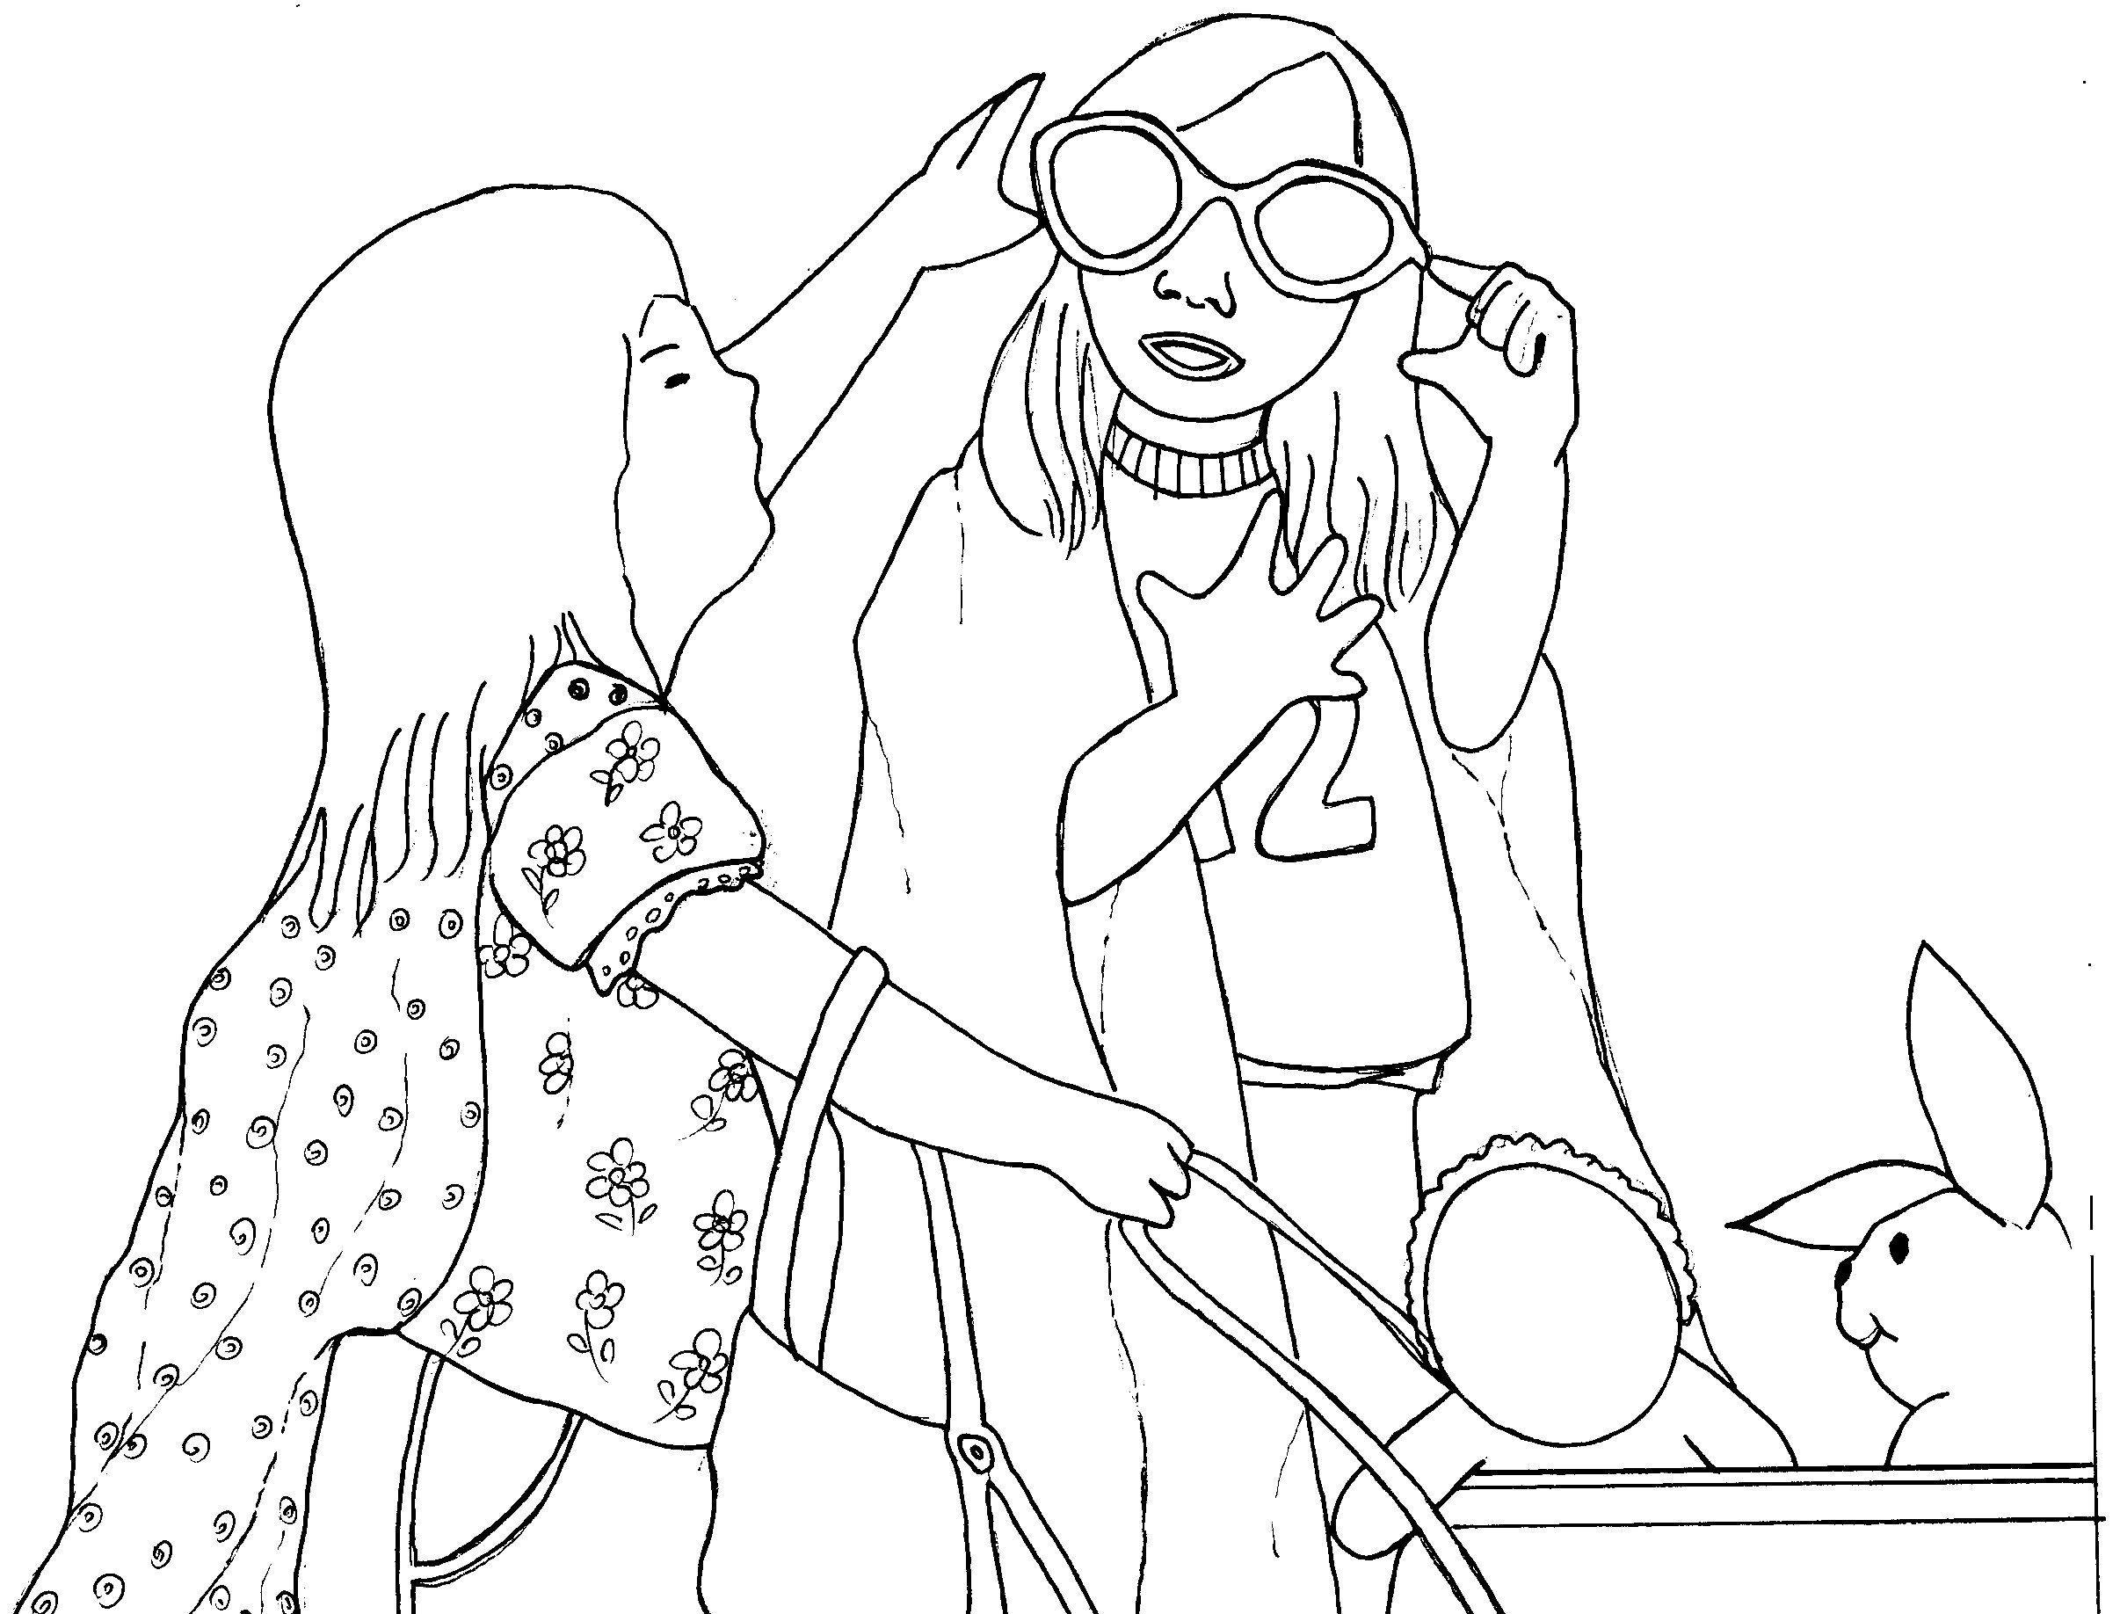
家長簽名：（ ）

